Simulation of Pyridine–Water Separation via Heterogeneous Azeotropic Distillation
Mr. Ivica MARJANOVIC
UPMC – Université Pierre et Marie Curie, Paris – CAPGEMINI, Paris

Background & Description:

This project explores the simulation of a pyridine–water separation process using heterogeneous azeotropic distillation with Aspen HYSYS V11. The system includes two distillation columns designed to recover high-purity pyridine and water, using toluene as an entrainer.
The feed mixture forms a homogeneous azeotrope (pyridine–water), and the entrainer forms a heterogeneous azeotrope (water–toluene), enabling phase separation. The distillate of the first column is expected to separate into two immiscible liquid phases.
In this simulation, however, the decanter (V-100) was not successfully implemented in HYSYS, and the phase split was approximated manually.
Process Overview:
- Simulation Tool: Aspen HYSYS V11
- Thermodynamic Model: NRTL
- Feed Composition: ~77 mol% water, 23 mol% pyridine
- Entrainer: Toluene
Key Process Units:
- Distillation Column DC-01
  - Stages: 14
  - Feed Stage: 6
  - Reflux Ratio: 1.27
  - Bottoms Product: Pyridine (≥ 99.9 mol%)
  - Distillate: Water + Toluene (phase split approximated)
- Phase Split (V-100)
  - No decanter unit was successfully simulated.
  - Phase separation was assumed conceptually, based on literature behavior.
- Distillation Column DC-02
  - Stages: 10
  - Feed Stage: 6
  - Reflux Ratio: 0.5
  - Light Key in Bottoms: Water (0.999)
  - Heavy Key in Distillate: Pyridine (0.005)
  - Bottoms Product: Water (≥ 99.9 mol%)
Results & Limitations:
- The simulation achieved:
  - High-purity pyridine recovery in DC-01
  - High-purity water recovery in DC-02
  - Pyridine loss reduction through recycling
However, the decanter unit (V-100) could not be properly modeled in Aspen HYSYS. As a result, the liquid–liquid phase separation step was only approximated manually, without a rigorous simulation of equilibrium behavior.
This limitation prevents the simulation from being considered fully reliable or complete, especially for evaluating the recycle stream composition and dynamics.

Flowsheet
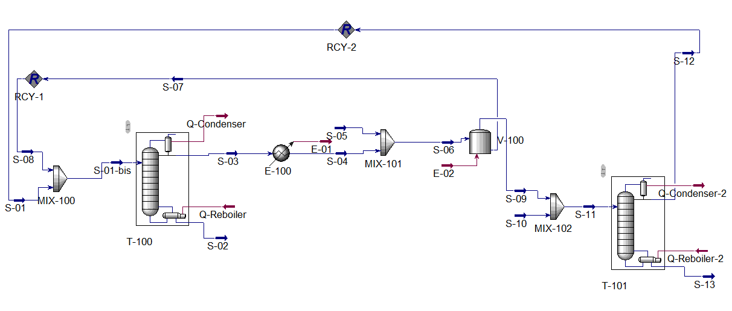
Results:

Master Property Tableau
Object | S-01-bis | S-02 | S-03 | S-11 | S-12 | S-13
T (°C) | 25.00 | 118.6 | 113.9 | 25.00 | 93.47 | 99.45
P (bar) | 1.013 | 1.115 | 1.115 | 1.013 | 1.013 | 1.013
Molar Flow  (kgmole/h) | 1.116e+08 | 1.800e+04 | 1.116e+08 | 1000 | 426.3 | 573.7
Mole Fract (H2O) | 0.0022 | 0 | 0.0022 | 0.9000 | 0.7667 | 0.9990
Mole Fract (Pyridine) | 0.7908 | 0.9992 | 0.7908 | 0.1000 | 0.2333 | 0.0010
Mole Fract (Toluene) | 0.2070 | 0.0008 | 0.2071 | 0 | 0 | 0
Nb : Insignificant quantities (<0) of components in the product streams can be considered negligible, effectively approximating them to zero without impacting the overall process results or conclusions (see flowsheet).
References: Wu, Y.-C., & Chien, I.-L. (2009). Design and Control of Heterogeneous Azeotropic Column System for the Separation of Pyridine and Water. Industrial & Engineering Chemistry Research, 48(23), 10564–10576.

